
NATIONAL INSTITUTE OF TECHNOLOGY PUDUCHERRY
(An Institution of National Importance under MHRD, Govt. of India)
KARAIKAL – 609 609

DEPARTMENT OF COMPUTER SCIENCE AND ENGINEERING
Roll Number: | CS19B1016 | Name | BOYINA AJAY SANTHOSH
Semester: | II | Class: | B TECH 1ST YEAR
Subject Code: | CS106 | Subject Name: | DATA STRUCTURES LABORATORY

4.1 : STACKS
Date:5.2.20

AIM:
To implement the stacks program by using c program.

ALGORITHM:

1. Start the program.
2. Define size of the array and declare stack array and top as globally.
3.By using switch statement we can perform push,pop,isempty and display as our wish ( outside while loop is there)
4. push : pushing the element from top of the stack.
5. pop : removing the element from top of the stack.
6. display : print the elements present in stack.
7. isempty: checks the condition whether the stack is empty or not.
8. stack follows lifo rule(last in first out)
9.close the program.

PROGRAM:
#include<stdio.h>
#include<conio.h>
#define N 5
int stack[N];
int top=-1;
void display();
void push();
void pop();
void peek();
void isempty();
int main()
{
int ch;
printf(" 1.push 2.pop 3.peek 4.display\n");
do
{
scanf("%d",&ch);
if(ch==1)
{
printf("the element which is pushed :\n");
}
switch(ch)
{
case 1:
push();
break;
case 2:
pop();
break;
case 3:
peek();
break;
case 4:
display();
break;
default:
printf("invalid choice\n");
}
}
while(ch!=0);
isempty();
getch();
}
void push()
{
int x;
scanf("%d",&x);
if(top==N-1)
printf("stack overflow\n");
else
{
top++;
stack[top]=x;
}
}
void pop()
{
int item;
printf(" POPPED ELEMENT IS : ");
if(top==-1)
printf("stack is empty\n");
else
{
item=stack[top];
printf(" %d\n",stack[top]);
top--;
}
}
void peek()
{

if(top==-1)
{
printf("stack is empty\n");
}
else
{
printf("Now top element is %d\n",stack[top]);
}
}
void display()
{
int i;
printf("\n DISPLAY : \n");
for(i=top;i>=0;i--)
{
printf("%d\t",stack[i]);
}
printf("\n");
}
void isempty()
{
if(top==-1)
printf("stack is empty\n");
else
printf("stack is not empty\n");
}

OUTPUT:

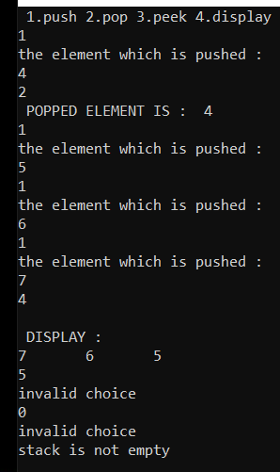

RESULT:

This program is successfully executed.

4.2 QUEUES
AIM:
To implement the queues through c program.

ALGORITHM:
1. Start the program.
2. declare the rear and front=-1 globally.
3. define queue array size and declare queue globally.
4. BY using switch statement, we can perform enqueue,dequeue,
peek,isempty,display etc(outside while loop).
5. enqueue : increment rear and push element from rear end only in queue.
6.dequeue : BY incrementing the front we can remove the previous element ( in other elements remove element from front end only)
7. display : printing all the elements present in queue.
8. isempty : it checks whether queue is empty or not
9. peek : first element present in queue.
10. close the program.

PROGRAM:
#include<stdio.h>
#include<conio.h>
#define N 5
int queue[N];
int rear=-1;
int front=-1;
void isempty();
void enqueue();
void dequeue();
void display();
void peek();
int main()
{
printf("THE ENQUEUED ELEMENTS ARE :\n");
enqueue(5);
enqueue(6);
enqueue(7);
enqueue(8);
printf("\n");
display();
dequeue();
peek(); // front()
dequeue();
peek();
isempty();
getch();

}
void enqueue(int x)
{
if(rear==-1 && front==-1)
{
rear=0;
front=0;
queue[rear]=x;
printf("%d\n",x);
}
else if(rear==N-1)
{
printf("queue is full\n");
}
else
{
rear++;
queue[rear]=x;
printf("%d\n",x);
}
}
void dequeue()
{
int item;
printf(" AFTER DEQUEUING :\n");
if(rear==-1 && front==-1)
{
printf("queue is empty\n");
}
else if(rear==front)
{
item=queue[front];
printf("the removed element is %d\n",item);
rear=-1;
front=-1;
}
else
{
item=queue[front];
printf("the removed element is %d\n",item);
front++;
}
printf("\n");
}
void display()
{
int i;
printf(" DISPLAY :\n");
if(rear==-1 && front==-1)
{
printf("queue is empty\n");
}
else
{
for(i=front;i<=rear;i++)
{
printf("%d\t",queue[i]);
}
}
printf("\n");
printf("\n");
}
void peek()
{
if(rear==-1 && front==-1)
{
printf("queue is empty\n");
}
else
{
printf("now the first element in queue is %d\n",queue[front]);
}
printf("\n");
}
void isempty()
{
if(rear==-1 && front==-1)
{
printf("queue is empty\n");
}
else
{
printf("queue is not empty\n");
}
}

OUTPUT:

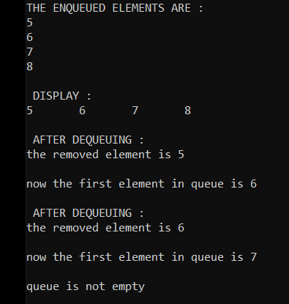

RESULT:

This program is successfully executed.

